New!

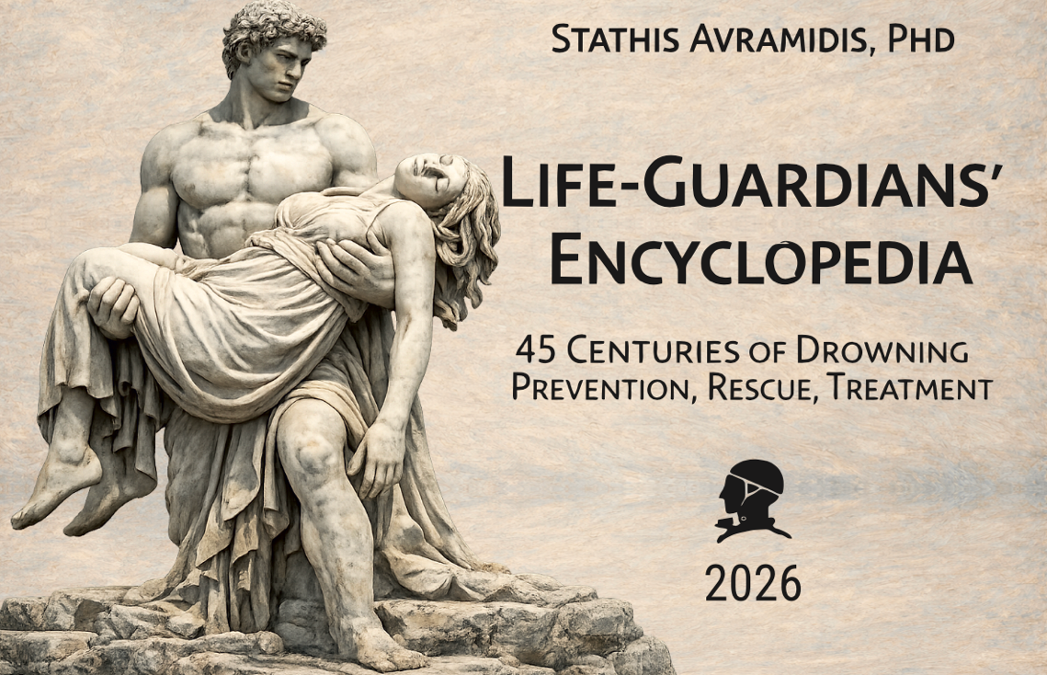

Life-Guardians Encyclopedia

45 Centuries of Drowning Prevention, Rescue & Treatment
The Life-Guardians Encyclopedia is the Who’s Who of the global effort to prevent drowning, rescue those in distress and treat the victims so that they may cheat death and survive. The President of Greek Life Saving, Dr Stathis Avramidis, has produced a mighty 891.8MB coffee table reference book weighing two kilos. The Encyclopedia covers five hundred pages of influential people who have significantly advanced the entire spectrum of aquatic survival through two decades of biennial World Conferences on Drowning Prevention. These conferences are now sponsored at global level by International Life Saving and the World Health Organization. You will be surprised to discover between its covers how many individuals you may already know personally, or at least have heard of when you open this philanthropic book.
The good news is that you can read this wonderous work in digital form for free and find out who is in it. Ancient Egyptians mix with legendary Greeks, Kings, Queens and Presidents along with Professors, Doctors, Life Guards, Swimming Teachers, Philanthropists and Administrators. They all have come together in a never-before-seen, global endeavour to reduce deaths by drowning. As Secretary of the Sri Lanka Women’s Project, I am very pleased to announce that you will find the Founder and Director of this Women’s Swimming Project, our Christina Fonfe´, on Pages 266-7 no less, in the Encylopedia, along with enthusiasts like the HM Queen Elizabeth II and President Reagan, to name two more. Age is no barrier; Christina, 77, and myself, 81, have just full requalified as Royal Life Saving Queensland licensed swimming teachers..
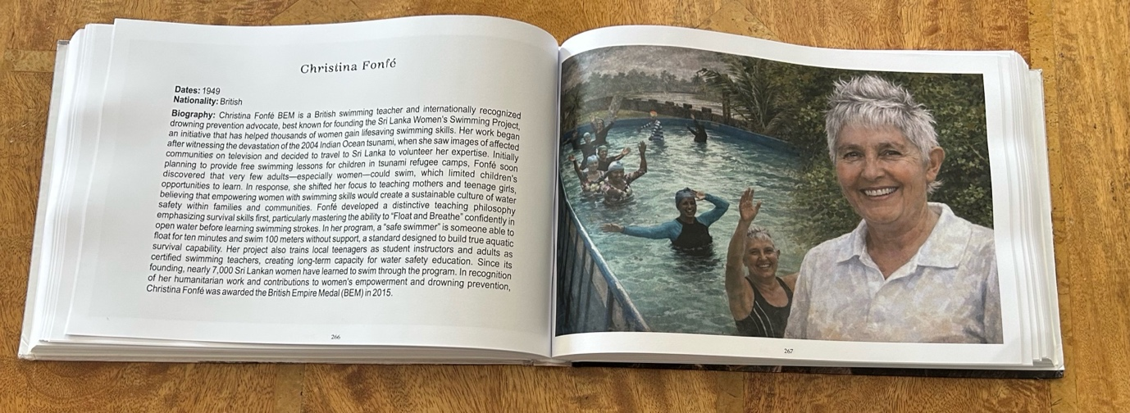
You can purchase a hardcopy or download a free PDF to read or print yourself:
http://sportlifesaving.blogspot.com/2026/04/life-guardians-encyclopedia.html
891.8MB 500 page PDF Version Download here.
Enjoy the exploration!

